IEEE WORKSHOP

Subject: Invitation to Speak at IEEE Workshop
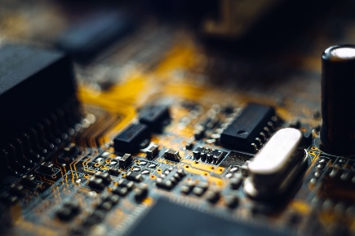
Dear Sam Altman
On behalf of the IEEE Club of SIT Nagpur, I would like to formally invite you to be our Guest Speaker for the upcoming workshop on "IEEE WORKSHOP."
We have been closely following your impactful work in Engineering cores and past contributions for our Club and believe that your insights would be incredibly valuable to our community of student innovators, researchers, and professional members.
The workshop is scheduled as follows:
• Date: 29/09/2026
• Time: 10:00am to 2:00 pm IST
• Venue/Platform: IEEE Lab
We would be honored if you could deliver a session approximately 30 minutes, followed by a brief Q&A session with the participants.
Please let us know your availability by [Confirmation Deadline]. Once you accept, we will share the logistical details and final agenda.
Thank you for considering our invitation. We hope to have the privilege of hosting you.
Sincerely,
Shrijit Burade
IEEE Club Head
Section- B (SIT,CSE)

